

A Report

on

**HOTEL MANAGEMENT SYSTEM**

Submitted By:

**Name Enrollment No.**

**ANKIT SENJALIYA 19BT04046**

**NIKUNJ SANGHANI 19BT04044**

**SAGAR VAKANI 19BT04058**

**DARSHAN GOLANI 19BT04010**

IN

COMPUTER SCIENCE AND ENGINEERING

**Page 1**

INDEX (TABLE OF CONTENTS)

Certificate………………………………………………………………. 5

Acknowledgement………………………………………………………5

Abstract………………………………………………………………… 6

1). Introduction…………………………...……………………….. 7 to 8

1.1) Project Summary………………….……………………………. 7

1.2) Purpose……...……………………………………………….…. 7

1.3) Objectives…….……………………………………………...…. 7

1.4) Scope …….………………………...…………………………. ..7

1.5) Hardware And Software Requirement……………….…….…... 8

2). System Analysis and Design……………………...……...……9 to 12

2.1) Study of Current System………………………………………....9

2.2) Problemes and Weakness Of current System……………………9

2.3) Requirements of New System……………………………….......9

2.4) System Design…………………………………………....10 to 12

3.) Implementation and Screenshots……………………………..…… 13

4.) Limitations and Future Enhancements…………………….……….13

5.) Conclusion………………………………………………………….14

6.) References………………………………………………………….14

**Page 2**

**Abstract**

This project aims at creating on Hotel Management System which can be used by Admin and Customers. The admin to advise/publish the availability of rooms in different hotels and customers are checking the availability of room in required hotel. Customers should be able to know the availability of the rooms on a particular date to reserve in hotel. They should be able to reserve the available rooms according to their need in advance to make their stay comfortable. The Admin hands the booking information of customers. The users can register and log into the system. The administrator will know the details of reservation and daily income. The hotel department maintain the seat availability and booking details in certain database. This project provides high security to Admin and user information.

This application is specially developed to help hotel staff. The project Hotel Management manages and maintains the records of customers and room in the hotel.

The rooms have different categories such as Deluxe, Semi-Deluxe etc., So their charges and records will be maintained accordingly.

**Page 3**

1. **INTRODUCTION**
   1. **Project Summary :-**

This is software for managing the general activities of a hotel like booking of rooms, billing etc.

The purpose of this document is to collect, analyze and define high-level needs and features of the Hotel Management System. It focuses on the capabilities needed by the stakeholders, and the target users, and why these needs exist. The details of how the Hotel Management System fulfills these needs are detailed in the use – case and supplementary specifications.

* 1. **Purpose :-**

This software is aimed at facilitating the prompt, accurate and easy management of a hotel. It will be very helpful to the manager on the one hand and to the customers as they would be able to get good and fast service.

* 1. **Objectives :-**

The objective of Hotel Management System is to develop a project which maintains booking of rooms and handles accounts of a hotel. It is a window based application to be implemented in java.

* 1. **Scope :-**

In this software, the hotel manager can add new customers and manage that customer information. Restaurant manager can add restaurant bill in that customer bill. This Software works at all hotels that cater to a large number of customers and want to computerize the complete management process.

The first subsystem is a Reservation and Booking System to keep track of reservations and room availability.

**Page 7**

The second subsystem is the Tracking and selling Food System that charges the current room.

The third subsystem is a General Management Services and Automated Tasks System which generates reports to audit all hotel operations and allows modification of subsystem information.

* 1. **Hardware and Software Requirements :-**

* **Hardware Requirements**

* Hard disk :- 500 GB
* RAM :- 8 GB
* System :- Intel Core I3 Processor.
* Monitor :- Standard LED Monitor.
* Input Devices :- Keyboard
* **Software Requirements**
* Languages :- Java
* Technologies :- NetBeans IDE 8.2
* Data base :- My SQL
* Operating System :- Windows 10

**Page 8**

1. **SYSTEM ANALYSIS AND DESIGN**

**2.1 Study of Current System :-**

Current system for hotel management is fully based on paper work. Hotel Management has to manage all records of customers, all records of rooms, all records of employee and rooms in papers.

**2.2 Problems and Weaknesses of Current System :-**

Paperwork is tedious job. There is delay and the problem of human error in allotting rooms and providing services.

**2.3 Requirements of New System :-**

**2.3.1 User Requirements**

There should be software which allocate rooms automatically and maintain records of customers and generate bill automatically for customers.

**2.3.2 System Requirements**

There should be database backup of Hotel Management System. There should be Java supported framework for the system. Operating system should be Windows XP or higher version of Windows.

**Page 9**

**2.4 System Design :-**

* **Flow Chart**

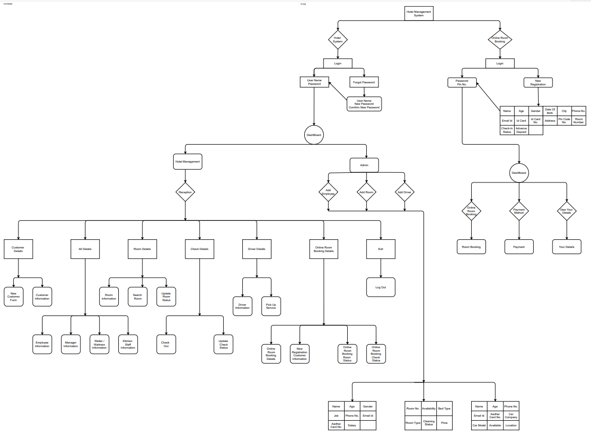

* **Class Diagram (Class Table for MY SQL)**
* **Login Class**

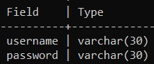

**Page 10**

* **Add Employee Class**

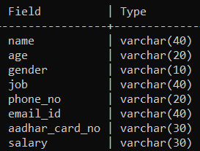

* **Add Room Class**

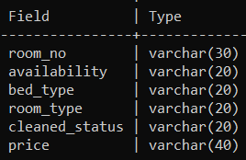

* **Add Driver Class**

**Page 11**

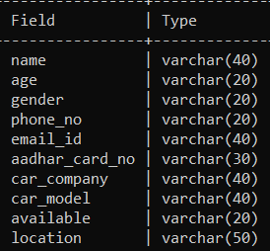

* **New Customer Details Class**

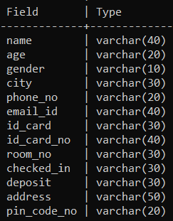

**Page 12**

1. **IMPLEMENTATION AND SCREEN SHOTS**

* **The Code Is In Another File**
* **Code**
* **Screen Shots Of The Output**

1. **LIMITATION AND FUTURE ENHANCEMENT**

* **Limitation :-**

The limitation of our present software is that this is desktop based software and we cannot reserve rooms in advance for customer. This project can’t be used for hotel having different branches.

* **Future Enhancement :-**

We are going to make online web-based application for this system so customer can automatically find rooms and reserve their rooms in advance.

**Page 13**

1. **CONCLUSION**

This project is designed to meet the requirements of Online Hotel Management java project report. It has been developed in VB & Mas – Access keeping in mind the specifications of the system. For designing the system we have used simple data flow diagrams. Free Project on Hotel Management System Project. Overall the project teaches us the essential skills like:

* Using System analysis and design techniques like data flow diagram in designing the system.
* Understanding the database handling and query processing. Free Project on Hotel Management System Project

1. **REFERENCES**

* **Google.com**
* **Testing Software**

**Page 14**